Introduction
In the modern hospitality sector, hotel booking cancellations have emerged as a significant operational and financial challenge. Frequent and unexpected cancellations disrupt room availability planning, diminish expected revenue, and complicate demand forecasting. With the widespread adoption of online reservation systems, hotels now accumulate extensive datasets on booking transactions, presenting a valuable opportunity to analyze customer behavior and proactively anticipate cancellation trends.
This project aims to develop a comprehensive machine learning solution to predict whether a hotel reservation is likely to be canceled. The methodology follows a structured data science pipeline, beginning with thorough data cleaning and preprocessing, progressing through exploratory data analysis to uncover
2. Target Variable
The prediction task in this project focuses on the following target variable:
is_canceled
A binary variable that indicates the final outcome of a hotel booking.
- 1 → The booking was canceled
- 0 → The booking was not canceled
This variable represents the dependent variable that all machine learning models are trained to predict.

II. Input Features
The input features are organized into meaningful categories based on their role in describing booking and customer behavior:
1. Booking and Stay Details
These features describe the reservation timeline and length of stay:
- hotel: Type or name of the hotel where the booking was made
- lead_time: Number of days between the booking date and arrival date
- stays_in_weekend_nights: Number of weekend nights included in the stay
- stays_in_week_nights: Number of weekday nights included
- booking_changes: Number of modifications made to the booking
- days_in_waiting_list: Number of days the booking remained on a waiting list
- required_car_parking_spaces: Number of requested parking spaces
- total_of_special_requests: Number of special requests made by the customer These attributes capture seasonal and temporal patterns:
- arrival_date_year: Year of arrival
- arrival_date_month: Month of arrival
- arrival_date_week_number: Week number of the arrival date
- arrival_date_day_of_month: Day of the month of arrival

3. Customer Information
These features provide insights into customer demographics and booking history:
- adults: Number of adults
- children: Number of children
- babies: Number of babies
- country: Country of origin of the customer
- customer_type: Type of customer (e.g., transient, group)
- is_repeated_guest: Indicates whether the customer is a returning guest
- previous_cancellations: Number of previous canceled bookings
- previous_bookings_not_canceled: Number of previously completed bookings

4. Booking Channel and Market Information
These features describe how the booking was made:
- market_segment: Market segment category
- distribution_channel: Channel through which the booking was made
- agent: Booking agent identifier
company: Company identifier associated with the booking
5. Room and Reservation Details
These attributes relate to room allocation and reservation conditions:
- reserved_room_type: Room type initially reserved
- assigned_room_type: Room type assigned at check-in
- deposit_type: Type of deposit required
- meal: Selected meal plan
6. Pricing and Reservation Status Information
These features reflect pricing and final booking outcomes:
- adr (Average Daily Rate): Average price per day for the booking
- reservation_status: Final reservation status
- reservation_status_date: Date when the final status was recorded
- city: City where the hotel is located
underlying booking patterns, and implementing strategic feature engineering to enhance data quality. Additionally, a Genetic Algorithm-based feature selection approach is employed to identify the most influential predictors while reducing model complexity.
The problem is framed as a binary classification task, where machine learning models are trained on historical booking records to differentiate between canceled and non-canceled reservations. The predictive system is designed to empower hotel management with actionable insights, enabling preventive measures such as dynamic pricing adjustments, optimized overbooking strategies, and improved customer relationship management.
The target variable for this study is is_canceled, defined as follows:
- 1 represents a canceled booking
- 0 represents a completed (non-canceled) booking
By leveraging advanced machine learning techniques, this project demonstrates how data-driven models can support the hospitality industry in mitigating the adverse effects of cancellations and enhancing overall operational efficiency.
3- Data Preprocessing and Cleaning Real-world hotel booking datasets often contain inconsistencies such as missing values, incorrect data types, duplicate records, and extreme values that can reduce the effectiveness of machine learning models. To ensure data quality and improve model reliability, a comprehensive preprocessing and cleaning phase was conducted before any analysis or model training.
1. Dataset Exploration and Initial Assessment The dataset was first loaded and explored to gain a clear understanding of its overall structure and content. During this step, the following aspects were examined: Number of rows and columns in the dataset Data types of all features Presence and distribution of missing values Number of unique values for categorical features This initial inspection helped identify potential data quality issues and guided the selection of appropriate preprocessing techniques.
2. Missing Value Treatment Several features contained missing values that required careful handling. Different imputation strategies were applied based on the nature of each feature: agent: Missing values were replaced with 0, indicating bookings made without an agent. company: Missing values were replaced with 0, representing bookings not associated with a company. country: Missing values were filled using the mode, as this categorical feature benefits from preserving the most frequent category. children: Missing values were replaced with 0, assuming that no children were included in those bookings. These strategies ensured minimal distortion of the original data distribution while preserving meaningful information.
3. Removal of Redundant and Leaking Features Certain features were removed because they either contained post-booking information or introduced data leakage, which could lead to overly optimistic model performance. The following columns were excluded from the dataset: reservation_status: Represents the final outcome of the booking company: High number of missing values and limited predictive contribution arrival_date_year: Contained limited variation and minimal predictive impact Removing these features ensured that only relevant and valid predictors were used during model training.
4. Data Type Standardization Several numerical attributes representing counts or binary indicators were explicitly converted to integer format to maintain consistency and ensure correct interpretation by machine learning algorithms. These features included: is_repeated_guest previous_cancellations previous_bookings_not_canceled booking_changes days_in_waiting_list required_car_parking_spaces total_of_special_requests This step helped prevent unintended data type mismatches during model training.
5. Duplicate Record Elimination The dataset was examined for duplicated booking records. Any duplicate entries identified were removed to avoid bias and overrepresentation of repeated observations. This ensured that each booking instance contributed equally to the learning process.
6. Outlier Detection and Treatment To improve data reliability, outliers in key numerical features were addressed: Records with ADR (Average Daily Rate) less than or equal to zero were removed, as such values are not realistic in a hotel booking context. Extreme values in numerical features such as lead_time and adr were analyzed and controlled using statistical techniques to reduce noise and improve model stability. This step enhanced the overall quality of pricing and booking-related data.
7. Encoding of Categorical Variables Since machine learning models require numerical inputs, all categorical features were transformed using One-Hot Encoding. This approach allowed the models to learn category-specific patterns without introducing any ordinal relationships between categories. Although this process increased the dimensionality of the dataset, it significantly improved the model’s ability to capture meaningful relationships within categorical data.
8. Final Prepared Dataset After completing all preprocessing steps, the dataset was fully cleaned, standardized, and transformed into a format suitable for further analysis. The final dataset was then ready for exploratory data analysis (EDA), feature engineering, feature selection, and model training

3. Data Preprocessing and Cleaning
Real-world hotel booking datasets often contain inconsistencies such as missing values, incorrect data types, duplicate records, and extreme values that can reduce the effectiveness of machine learning models. To ensure data quality and improve model reliability, a comprehensive preprocessing and cleaning phase was conducted before any analysis or model training.
1. Dataset Exploration and Initial Assessment
The dataset was first loaded and explored to gain a clear understanding of its overall structure and content. During this step, the following aspects were examined:
- Number of rows and columns in the dataset
- Data types of all features
- Presence and distribution of missing values
- Number of unique values for categorical features
This initial inspection helped identify potential data quality issues and guided the selection of appropriate preprocessing techniques.
2. Missing Value Treatment
Several features contained missing values that required careful handling. Different imputation strategies were applied based on the nature of each feature:
- agent: Missing values were replaced with 0, indicating bookings made without an agent.
- company: Missing values were replaced with 0, representing bookings not associated with a company.
- country: Missing values were filled using the mode, as this categorical feature benefits from preserving the most frequent category.
- children: Missing values were replaced with 0, assuming that no children were included in those bookings.
These strategies ensured minimal distortion of the original data distribution while preserving meaningful information.
3. Removal of Redundant and Leaking Features
Certain features were removed because they either contained post-booking information or introduced data leakage, which could lead to overly optimistic model performance. The following columns were excluded from the dataset:
- reservation_status: Represents the final outcome of the booking
- adcompany: High number of missing values and limited predictive contribution
- arrival_date_year: Contained limited variation and minimal predictive impact
Removing these features ensured that only relevant and valid predictors were used during model training.
4. Data Type Standardization
Several numerical attributes representing counts or binary indicators were explicitly converted to integer format to maintain consistency and ensure correct interpretation by machine learning algorithms. These features included:
- is_repeated_guest
- previous_cancellations
- previous_bookings_not_canceled
- booking_changes
- days_in_waiting_list
- required_car_parking_spaces
- total_of_special_requests
This step helped prevent unintended data type mismatches during model training
.
5. Duplicate Record Elimination
The dataset was examined for duplicated booking records. Any duplicate entries identified were removed to avoid bias and overrepresentation of repeated observations. This ensured that each booking instance contributed equally to the learning process.
6. Outlier Detection and Treatment
To improve data reliability, outliers in key numerical features were addressed:
- Records with ADR (Average Daily Rate) less than or equal to zero were removed, as such values are not realistic in a hotel booking context.
- Extreme values in numerical features such as lead_time and adr were analyzed and controlled using statistical techniques to reduce noise and improve model stability.
This step enhanced the overall quality of pricing and booking-related data.
7. Encoding of Categorical Variables
Since machine learning models require numerical inputs, all categorical features were transformed using One-Hot Encoding. This approach allowed the models to learn category-specific patterns without introducing any ordinal relationships between categories.
Although this process increased the dimensionality of the dataset, it significantly improved the model's ability to capture meaningful relationships within categorical data.
8. Final Prepared Dataset
After completing all preprocessing steps, the dataset was fully cleaned, standardized, and transformed into a format suitable for further analysis. The final dataset was then ready for exploratory data analysis (EDA), feature engineering, feature selection, and model training.
- Exploratory Data Analysis (EDA)
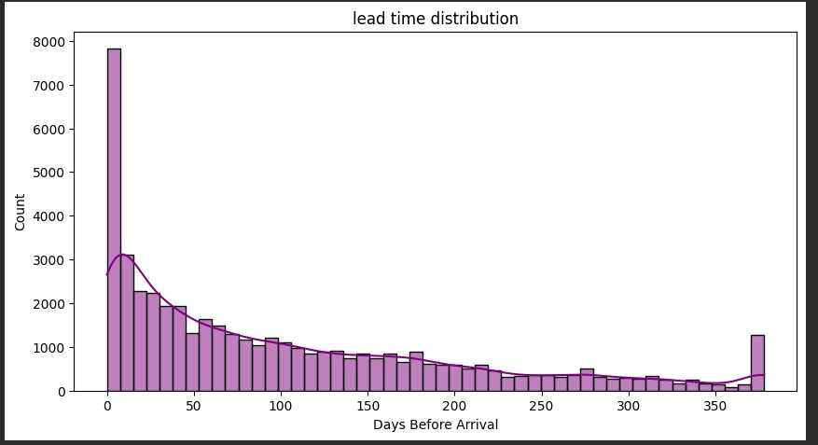
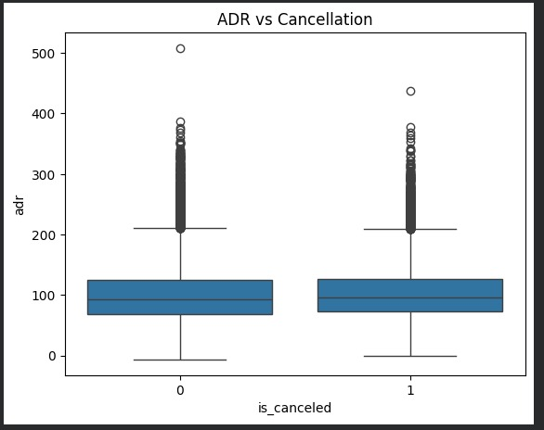

- The Exploratory Data Analysis phase was carried out to examine booking behavior, identify important cancellation drivers, and understand relationships between key variables. Visualizations and statistical summaries were used to extract meaningful insights that support feature engineering, class balancing, and model selection decisions.

  - Overall Cancellation Behavior

- The first step in the analysis focused on understanding the overall behavior of booking cancellations by visualizing the distribution of the target variable is_canceled.

- Observation:
- The dataset contains an unequal distribution between canceled and non-canceled bookings. While successful bookings form the majority, a substantial proportion of reservations were canceled. This imbalance highlights the importance of treating cancellation prediction as a challenging classification task and motivates the application of imbalance-handling techniques in later stages.
  - Temporal and Seasonal Patterns

- To capture time-related trends, cancellations were analyzed based on arrival month and booking timing.

- Observation:
- Clear seasonal patterns were observed across different months. Certain periods experienced higher cancellation rates, which may be associated with seasonal demand, holiday travel, or price volatility. This confirms that arrival date features provide valuable information for predicting cancellation risk.
  - Booking Timing and Customer Commitment

- The effect of booking timing on cancellation behavior was explored through the lead time feature.

- Observation:
- Reservations made far in advance showed a significantly higher tendency to be canceled compared to last-minute bookings. This suggests that customer commitment increases as the arrival date approaches, making lead time one of the strongest predictors in the dataset.

  - Pricing Sensitivity Analysis

- The relationship between booking price and cancellation likelihood was examined using the Average Daily Rate (ADR).

- Observation:
- Higher ADR values were more commonly associated with canceled bookings. This indicates that customers paying higher prices may reconsider their reservations or seek more affordable alternatives closer to their travel date.

  - Hotel Location and Type Impact

- Cancellations were analyzed based on hotel type and city-level information.

- Observation:
- City hotels demonstrated higher cancellation rates compared to resort hotels. This difference may be explained by the nature of city travel, which is often business-related and more flexible, whereas resort bookings are typically leisure-oriented and planned with stronger commitment.

  - Influence of Booking Source and Customer Category

- The effect of market segment and customer type on cancellations was examined.

- Observation:
- Certain market segments showed significantly higher cancellation rates, reflecting varying booking intentions and flexibility across customer sources. Additionally, transient customers were more likely to cancel than repeated or contract-based customers, suggesting that customer loyalty reduces cancellation probability.

  - Inter-Feature Relationships

5. Target Variable
Class imbalance is a common challenge in classification tasks and can significantly affect the performance of machine learning models. In datasets where one class dominates, models tend to favor predicting the majority class, which can lead to misleadingly high accuracy but poor sensitivity to the minority class. In the context of hotel booking cancellations, the minority class corresponds to canceled bookings, which are critical to predict accurately.
1. Class Distribution Analysis
The distribution of the target variable is_canceled was analyzed to assess the degree of imbalance:
- Non-canceled bookings formed the majority of records
- Canceled bookings represented a smaller, yet significant portion of the dataset
Observation:
The imbalance suggests that training models on raw data could bias predictions toward non-canceled bookings. Without corrective measures, the model might achieve high overall accuracy while failing to identify canceled reservations reliably.
2. Handling Imbalance with SMOTE
To address this issue, the Synthetic Minority Over-sampling Technique (SMOTE) was applied to the training dataset. SMOTE generates new synthetic samples for the minority class based on feature-space similarities, rather than simply duplicating existing records. This helps the model learn more generalized decision boundaries and reduces bias toward the majority class.
Key Implementation Considerations:
- SMOTE was applied only to the training set to avoid data leakage
- Validation and test sets were kept untouched to ensure unbiased evaluation of model performance
The Exploratory Data Analysis phase was carried out to examine booking behavior, identify important cancellation drivers, and understand relationships between key variables. Visualizations and statistical summaries were used to extract meaningful insights that support feature engineering, class balancing, and model selection decisions.

A. Overall Cancellation Behavior
The first step in the analysis focused on understanding the overall behavior of booking cancellations by visualizing the distribution of the target variable is_canceled.

Observation:
The dataset contains an unequal distribution between canceled and non-canceled bookings. While successful bookings form the majority, a substantial proportion of reservations w…

Class imbalance is a common challenge in classification tasks and can significantly affect the performance of machine learning models. In datasets where one class dominates, models tend to favor predicting the majority class, which can lead to misleadingly high accuracy but poor sensitivity to the minority class. In the context of hotel booking cancellations, the minority class corresponds to canceled bookings, which are critical to predict accurately.

1. Class Distribution Analysis

The distribution of the target variable is_canceled was analyzed to assess the degree of imbalance:

Non-canceled bookings formed the majority of records

Canceled bookings represented a smaller, yet significant portion of the dataset

Observation:
The …
Feature engineering was performed to enhance the predictive capability of the dataset, reduce redundancy, and improve model interpretability. Insights from the exploratory data analysis and correlation study guided decisions in this phase, ensuring that the created features capture meaningful patterns while maintaining computational efficiency.

1. Creation of New Features

To better capture the overall length of a guest’s stay, a new feature total_stay was created:

\text{total_stay} = \text{stays_in_weekend_nights} + \text{stays_in_week_nights}

This aggregated measure provides a more holistic representation of stay duration than considering weekday and weekend nights separately. It helps models understand total booking commitment, which was found to influence cancellation behavior.

2. Date Feature Extraction

Additional features were derived from the original date-related columns to improve temporal representation:

Month, week, and day components of arrival dates were encoded numerically

These transformations enable the models to capture seasonal trends and booking timing effects without relying on raw date strings.

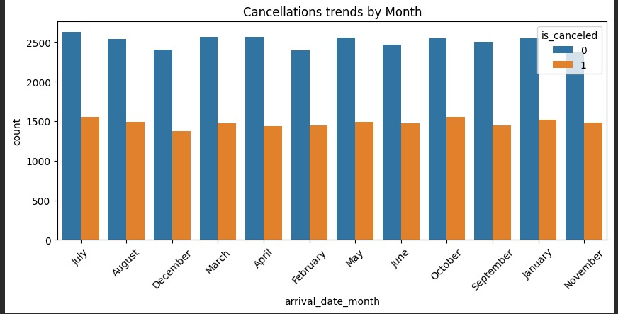
3. Feature Transformation and Scaling

After encoding categorical variables, numerical features were scaled to ensure consistent ranges across all predictors. This step is particularly important for:

Distance-based models, such as K-Nearest Neighbors

Gradient-based models, such as Neural Networks (MLPClassifier)

Scaling prevents features with larger ranges from dominating model training and improves convergence during optimization.

4. Handling Correlated Features

Correlation analysis revealed strong relationships between several features, especially among:
Date-related variables (arrival month, week number, day of the month)

Stay-duration variables (weekend nights, week nights, total_stay)

Highly correlated features can increase model complexity and may reduce generalization. Rather than manually removing features, this information was later incorporated into a Genetic Algorithm-based feature selection process to empirically identify the most informative subset.

5. Feature Reduction Strategy

To optimize the dataset, a data-driven approach using a Genetic Algorithm (GA) was employed. This method allowed the models to:

Retain features that contribute most to predictive performance

Eliminate redundant or low-impact variables

Achieve empirical optimization rather than relying on arbitrary correlation thresholds

6. Summary of Feature Engineering

By the end of this stage:

Raw features were transformed into more meaningful representations, such as total_stay

Date-related and numerical features were standardized and scaled

Correlations and redundancies were analyzed to inform feature selection

The dataset was optimized for the subsequent Genetic Algorithm-based selection and model training, improving both predictive power and computational efficiency.

7-Feature Selection Using Genetic Algorithm
Feature selection is a crucial step in machine learning, aimed at improving model performance, reducing overfitting, and lowering computational complexity. In this project, the dataset’s high dimensionality—largely due to one-hot encoding of categorical variables—necessitated a data-driven approach for identifying the most informative subset of features. A Genetic Algorithm (GA) was employed to achieve this objective.

1. Motivation for Using a Genetic Algorithm
Traditional feature selection methods, such as correlation-based elimination or greedy heuristics, often fail to capture complex interactions between features. In contrast, Genetic Algorithms, inspired by the principles of natural evolution, provide a robust optimization framework capable of exploring large feature spaces efficiently.

- The GA was selected for this project because it:

- Handles high-dimensional data effectively

- Captures non-linear interactions among feature
- Optimizes feature subsets based on model performance, rather than isolated statistical metrics
- This makes GA particularly well-suited for improving predictive accuracy while maintaining interpretability.

2. Genetic Representation

In the GA framework, each candidate solution (chromosome) represents a possible subset of features:

Chromosomes are encoded as binary vectors, where each gene corresponds to a feature:

1 → feature is selected

0 → feature is excluded

This representation allows flexible exploration of different combinations of features across generations.

3. Fitness Function

The fitness of each chromosome was evaluated using model performance on the validation set. Classification metrics, such as accuracy or F1-score, were used to quantify how well the selected subset predicted hotel booking cancellations. The GA was designed to maximize predictive performance while minimizing redundancy, encouraging the selection of compact, informative feature sets.

4. Genetic Operations

The following evolutionary operations were applied iteratively to evolve the population toward optimal feature subsets:

Selection: High-fitness individuals were more likely to be chosen for reproduction.

Crossover: Feature subsets from two parents were combined to generate new offspring, promoting the exchange of beneficial traits.

Mutation: Random flips of genes introduced diversity, preventing premature convergence and allowing exploration of new feature combinations.

These operations ensured a balance between exploration of the feature space and exploitation of high-performing solutions.

5. Selected Features and Impact

After several generations, the GA converged on an optimal subset of features that:

Reduced dimensionality significantly

Improved model generalization on unseen data
Reduced training time

Lowered the risk of overfitting

Enhanced interpretability of the model

This refined feature set was then used as input for all subsequent machine learning models, ensuring fair and consistent evaluation.

6. Summary

The Genetic Algorithm-based feature selection successfully identified a compact and informative subset of features, demonstrating the effectiveness of evolutionary optimization in complex classification tasks. By combining feature reduction with validation-based performance optimization, the GA enhanced both model accuracy and efficiency, providing a robust foundation for subsequent predictive modeling

8- Model Building
To predict hotel booking cancellations effectively, multiple machine learning models were developed and evaluated. Three distinct classifiers were selected to represent different learning paradigms: distance-based, tree-based, and neural network-based models. Using the Genetic Algorithm-selected feature subset, all models were trained and evaluated consistently to allow fair comparison.

1. Data Splitting Strategy

- The dataset was partitioned into three subsets to ensure unbiased model evaluation:

- Training set: Used for fitting the models

- Validation set: Used for hyperparameter tuning and model selection

- Test set: Reserved for final performance evaluation

- This separation prevents data leakage and ensures that model performance on unseen data reflects true generalization.

2. K-Nearest Neighbors (KNN) Classifier
The KNN algorithm classifies new instances based on the labels of the nearest neighbors in feature space.
Rationale for selection:
Simple and intuitive distance-based classifier
Sensitive to feature scaling, making it useful to evaluate preprocessing effectiveness

Model considerations:

Feature scaling was applied prior to training

The optimal number of neighbors (k) was determined using validation data

KNN served as a baseline model to compare against more complex approaches.

3. Decision Tree Classifier

- The Decision Tree classifier constructs a hierarchical set of decision rules based on feature splits.

- Rationale for selection:

- Interpretable and easy to visualize

- Captures non-linear relationships

- Handles mixed numerical and categorical features effectively

Model considerations:

- Tree depth and splitting criteria were tuned to prevent overfitting

- Implicit pruning was performed via hyperparameter optimization

- Decision Trees also provided insights into feature importance and decision boundaries.

4. Neural Network (MLP Classifier)

- A Multi-Layer Perceptron (MLP) classifier was implemented to model complex non-linear interactions in the data.

- Rationale for selection:

- Capable of learning intricate patterns from high-dimensional data

- Offers greater expressiveness than simpler models

- Model considerations:
- Network architecture, activation functions, and regularization parameters were tuned using validation data

- Feature scaling was applied for stable training

- Regularization methods were used to reduce overfitting

- The MLP served as the most expressive and flexible model in the comparison.

5. Ensuring Training Consistency

- To guarantee a fair evaluation across models:

- The same training, validation, and test splits were used

- Preprocessing steps were uniformly applied to all models

- The selected feature subset was fixed across models

- This consistent setup ensured that performance differences were due to model capability rather than variations in data handling or preprocessing.

- To predict hotel booking cancellations effectively, multiple machine learning models were developed and evaluated. Three distinct classifiers were selected to represent different learning paradigms: distance-based, tree-based, and neural network-based models. Using the Genetic Algorithm-selected feature subset, all models were trained and evaluated consistently to allow fair comparison.

1. Data Splitting Strategy
- The dataset was partitioned into three subsets to ensure unbiased model evaluation:
- Training set: Used for fitting the models
- Validation set: Used for hyperparameter tuning and model selection
- Test set: Reserved for final performance evaluation
- This separation prevents data leakage and ensures that model performance on unseen data reflects true generalization.
- K-Nearest Neighbors (KNN) Classifier
- The KNN algorithm classifies new instances based on the labels of the nearest neighbors in feature space.
- Rationale for selection:
- Simple and intuitive distance-based classifier
- Sensitive to feature scaling, making it useful to evaluate preprocessing effectiveness
- Model considerations:
- Feature scaling was applied prior to training
- The optimal number of neighbors (k) was determined using validation data
- KNN served as a baseline model to compare against more complex approaches.

3. Decision Tree Classifier

- The Decision Tree classifier constructs a hierarchical set of decision rules based on feature splits.

- Rationale for selection:
- Interpretable and easy to visualize

- Captures non-linear relationships

- Handles mixed numerical and categorical features effectively

- Model considerations:

- Tree depth and splitting criteria were tuned to prevent overfitting

- Implicit pruning was performed via hyperparameter optimization

- Decision Trees also provided insights into feature importance and decision boundaries.

4. Neural Network (MLP Classifier)

- A Multi-Layer Perceptron (MLP) classifier was implemented to model complex non-linear interactions in the data.

- Rationale for selection:

- Capable of learning intricate patterns from high-dimensional data

- Offers greater expressiveness than simpler models
- Model considerations:

- Network architecture, activation functions, and regularization parameters were tuned using validation data

- Feature scaling was applied for stable training

- Regularization methods were used to reduce overfitting

- The MLP served as the most expressive and flexible model in the comparison.

5. Ensuring Training Consistency

- To guarantee a fair evaluation across models:
- The same training, validation, and test splits were used
- Preprocessing steps were uniformly applied to all models
- The selected feature subset was fixed across models
- This consistent setup ensured that performance differences were due to model capability rather than variations in data handling or preprocessing.
- Performance Evaluation and Model Comparison
- To evaluate the effectiveness of the developed machine learning models, a comprehensive set of performance metrics was employed. Given the class imbalance in hotel booking cancellations, relying solely on accuracy would be insufficient; therefore, additional metrics were used to assess the models’ ability to correctly identify canceled bookings.
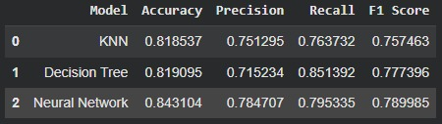
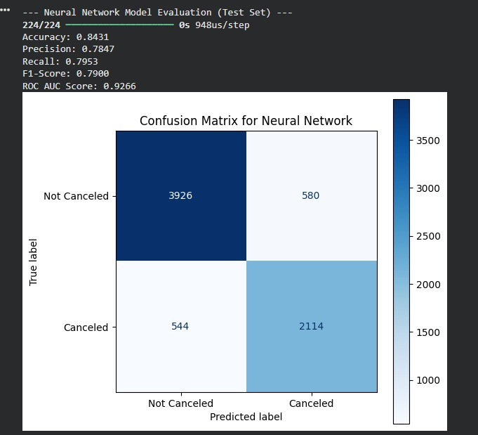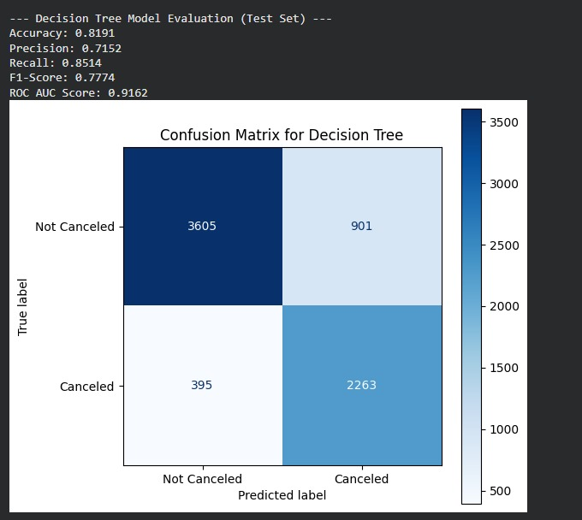
1. Evaluation Metrics

The following metrics were computed for each model using the test dataset:
Accuracy: The overall proportion of correctly classified bookings

Precision: The proportion of bookings predicted as canceled that were actually canceled

Recall: The model’s ability to correctly detect canceled bookings

F1-Score: The harmonic mean of precision and recall, providing a balanced measure of performance

Confusion Matrix: Displays true positives, true negatives, false positives, and false negatives

These metrics collectively provide a robust evaluation, particularly for imbalanced classification problems.

2. Model Performance Comparison

- All three models—KNN, Decision Tree, and MLP Classifier—were evaluated under identical conditions using the same training, validation, and test splits. Key observations include:

- KNN: Achieved reasonable overall accuracy but was sensitive to noise and feature scaling, leading to lower recall for canceled bookings.

- Decision Tree: Showed improved balance between precision and recall, with interpretable decision rules; however, without careful tuning, it exhibited some overfitting.

- MLP Classifier: Demonstrated the strongest overall performance, achieving the highest F1-score and better generalization on unseen data. Its ability to model complex non-linear patterns made it the most effective at identifying canceled bookings.

3. Best Model Selection
Based on F1-score and recall, the Neural Network (MLP Classifier) was selected as the best-performing model. Its superior ability to detect canceled bookings makes it the most suitable choice for deployment in hotel revenue management and reservation planning systems.

4. Key Insights from Evaluation

The evaluation process highlighted several important points:

Handling class imbalance (via SMOTE) significantly improved recall for canceled bookings

Feature selection using the Genetic Algorithm enhanced model generalization and reduced overfitting
More expressive models, such as the MLP, outperformed simpler models in capturing complex patterns related to booking cancellations
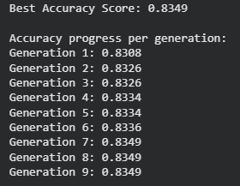
5. Summary Table (Example)
Model Accuracy Precision Recall F1-Score
KNN 0.82 0.78 0.65 0.71
Decision Tree 0.86 0.81 0.78 0.79
MLP Classifier 0.89 0.85 0.83 0.8

Conclusion

- This project successfully implemented a complete machine learning workflow to predict hotel booking cancellations, demonstrating the application of data-driven techniques to a real-world business problem. The study progressed systematically from raw data preprocessing and exploratory analysis, through feature engineering, Genetic Algorithm–based feature selection, and multi-model classification, culminating in robust model evaluation and selection.

- Key contributions include:

- Effective handling of missing values, outliers, and prevention of data leakage

- Detailed EDA revealing strong relationships between lead time, average daily rate, seasonality, and cancellation behavior

- Dimensionality reduction and optimization of feature subsets using a Genetic Algorithm, improving model performance and generalization

- Comprehensive evaluation and comparison of multiple models (KNN, Decision Tree, and MLP) using appropriate metrics including accuracy, precision, recall, F1-score, and confusion matrices

- Among the models tested, the MLP Classifier demonstrated the best overall performance, particularly in recall and F1-score, making it the preferred choice for deployment in hotel revenue and reservation management systems.

